
Hospital Management System

Group Memebers:
Shehryar Ali (030)
Shahzaib Khan (038)
Mahnoor Tariq (121)

Software Validation And Verification

Bachelor In Software Engineering

Table of Contents
- Abstract
- Introduction
2.1 Background of Hospital Management Systems
2.2 Problem Statement
2.3 Objectives of the Project
2.4 Scope of the System
- Literature Review
3.1 Traditional Hospital Management Systems
3.2 Importance of Formal Methods
3.3 Introduction to Alloy Analyzer
- System Analysis and Requirements
4.1 Functional Requirements
4.2 Non-Functional Requirements
4.3 System Constraints
- System Design
5.1 Core Entities
5.2 Patient Module
5.3 Doctor Module
5.4 Appointment Module
5.5 Relationship Modeling
- Alloy Model Specification
6.1 Signatures (sig)
6.2 Facts and Constraints
6.3 Predicates
6.4 Assertions
6.5 Run and Check Commands
- Implementation Details
7.1 Patient Entity Implementation
7.2 Doctor Entity Implementation
7.3 Appointment Entity Implementation
7.4 Validation Rules
7.5 Double Booking Prevention
- Testing and Verification
8.1 Model Verification
8.2 Assertion Checking
8.3 Instance Generation
8.4 Error Detection and Analysis
- Results and Discussion
9.1 Generated Instances
9.2 Constraint Validation
9.3 System Reliability Analysis
- Advantages of Using Formal Methods
- Challenges and Limitations
- Future Enhancements
- Conclusion
- References
- Appendix
15.1 Complete Alloy Code
15.2 Screenshots of Alloy Analyzer Output
15.3 Test Cases and Assertions

Abstract
The Hospital Management System is a formal modeling project developed using the Alloy Analyzer to represent and verify the core operations of a hospital environment. The system focuses on managing patients, doctors, and appointments while ensuring data consistency and correctness through formal constraints and logical rules. The model defines unique identities for patients, doctors, and appointments, prevents duplicate records, and validates relationships between entities. Special attention is given to appointment scheduling rules to avoid invalid or conflicting bookings.
The project demonstrates how formal methods can be used to model real-world systems accurately and detect inconsistencies before implementation. Using Alloy’s analysis and visualization capabilities, the system can automatically generate valid instances and verify assertions related to system correctness. This approach improves reliability, reduces ambiguity in requirements, and supports error detection during the design phase. The Hospital Management System serves as a simple yet effective example of applying formal specification techniques in software engineering for healthcare applications.

2. Introduction
Hospital management is one of the most important parts of the healthcare sector. Hospitals deal with a large amount of patient information, doctor records, appointment scheduling, and medical services every day. Managing all these operations manually can lead to errors, data loss, duplicate records, and scheduling conflicts. To improve efficiency and accuracy, computerized Hospital Management Systems are widely used.
This project presents a Hospital Management System modeled using the Alloy Analyzer formal specification language. The system focuses on managing patients, doctors, and appointments while ensuring data consistency through logical rules and constraints. The model verifies the correctness of the system before actual software implementation, reducing the chances of errors during development.
The project demonstrates how formal methods can help in designing reliable and secure healthcare systems. By using Alloy Analyzer, different scenarios and system conditions can be automatically tested and validated.
2.1 Background of Hospital Management Systems
A Hospital Management System (HMS) is a computerized system designed to manage the daily operations of hospitals and healthcare centers. It helps in storing patient information, managing doctor schedules, handling appointments, and maintaining hospital records efficiently.
Traditional manual systems require a large amount of paperwork and human effort. These systems are often slow and may produce errors such as duplicate patient records, incorrect appointments, and data inconsistency. With the advancement of technology, modern hospital systems use software solutions to automate these tasks and improve healthcare services.
Formal specification methods are now becoming important in software engineering because they allow developers to mathematically verify system behavior. Alloy Analyzer is one such tool that helps developers model systems, define constraints, and detect logical inconsistencies at the design stage.
The Hospital Management System developed in this project uses Alloy to model relationships between patients, doctors, and appointments while ensuring system correctness through verification techniques.
2.2 Problem Statement
In many hospitals, managing patient records and appointments manually can create several problems. Duplicate entries, invalid doctor assignments, incorrect scheduling, and inconsistent data may occur due to human errors. These issues can reduce the efficiency of hospital operations and affect patient care.
Another major problem is the lack of system verification during software development. Without proper validation, software systems may contain logical errors that are difficult to identify after implementation.
This project aims to solve these issues by developing a formally specified Hospital Management System using Alloy Analyzer. The system ensures:
- Unique identification of patients, doctors, and appointments
- Prevention of duplicate records
- Validation of positive IDs
- Correct relationships between entities
- Detection of inconsistencies through formal verification
2.3 Objectives of the Project
The main objectives of this project are:
- To develop a formal model of a Hospital Management System using Alloy.
- To represent patients, doctors, and appointments as system entities.
- To ensure uniqueness of IDs for all entities.
- To prevent duplicate or invalid appointments.
- To apply logical constraints and validation rules within the system.
- To verify system correctness using assertions and predicates.
- To generate valid system instances using Alloy Analyzer.
- To reduce logical and structural errors during the design phase.
2.4 Scope of the System
The scope of this project is limited to the core functionalities of a Hospital Management System. The system focuses mainly on managing:
- Patient records
- Doctor records
- Appointment scheduling
- Relationship validation between entities
The project uses Alloy Analyzer for formal specification and verification purposes only. It does not include advanced hospital functionalities such as billing systems, laboratory management, pharmacy management, or online payment systems.
3. Literature Review
The healthcare industry has increasingly adopted computerized systems to improve hospital operations and patient care. Hospital Management Systems (HMS) are designed to automate administrative and clinical activities such as patient registration, appointment scheduling, doctor management, and medical record handling. Over time, researchers and software developers have explored different techniques to improve the reliability, efficiency, and correctness of these systems.
Traditional software development methods mainly focus on implementation and testing after development. However, these approaches may fail to identify logical inconsistencies during the early stages of design. To overcome these limitations, formal methods have been introduced in software engineering. Formal methods use mathematical techniques to specify, model, and verify system behavior before implementation.
This project uses Alloy Analyzer as a formal modeling tool to design and verify a Hospital Management System. Alloy provides a simple yet powerful way to define entities, constraints, and relationships while automatically checking the correctness of the system model.

3.1 Traditional Hospital Management Systems
Traditional Hospital Management Systems were mostly manual and paper-based. Hospitals maintained patient records, doctor schedules, and appointment details using files and registers. These systems required a significant amount of human effort and were prone to several problems such as:
- Data duplication
- Record misplacement
- Appointment conflicts
- Slow information retrieval
- Human calculation errors
With technological advancements, computerized Hospital Management Systems replaced manual methods. These systems improved efficiency by automating hospital operations and reducing paperwork. Modern HMS applications provide features such as:
- Patient registration
- Electronic medical records
- Appointment scheduling
- Billing management
- Doctor and staff management
Although computerized systems improved hospital operations, many systems still face challenges related to software reliability and logical correctness. Errors in database design or appointment handling may still occur if the system is not properly verified during development.

3.2 Importance of Formal Methods
Formal methods are mathematical techniques used to specify, develop, and verify software systems. These methods help developers identify logical errors during the design phase rather than after implementation. Formal methods are especially important in critical systems such as healthcare, banking, aviation, and security systems where software failures can cause serious problems.
The main advantages of formal methods include:
- Early detection of logical inconsistencies
- Improved software reliability
- Better system validation and verification
- Reduction in development errors
- Clear and unambiguous system specifications
In healthcare systems, formal methods can ensure that patient records, doctor assignments, and appointments follow strict rules and constraints. By mathematically verifying the system model, developers can reduce the risk of duplicate data, invalid scheduling, and inconsistent relationships.
This project applies formal methods to model a Hospital Management System and verify its correctness using logical constraints and assertions.

3.3 Introduction to Alloy Analyzer
Alloy Analyzer is a lightweight formal specification and modeling tool developed for software analysis and verification. It uses a declarative modeling language based on first-order logic and relational algebra. Alloy allows developers to describe system structures, relationships, and constraints in a precise mathematical form.
The Alloy Analyzer automatically checks whether the defined constraints are logically consistent. It can generate sample instances of the system and identify counterexamples if any assertion fails. This feature makes Alloy highly useful for detecting design errors during the early stages of software development.
The main components of Alloy include:
- Signatures (sig): Define entities or objects in the system
- Facts: Specify rules and constraints that must always hold true
- Predicates: Describe reusable conditions or scenarios
- Assertions: Verify whether certain properties are always satisfied
- Run and Check Commands: Generate system instances and validate assertions

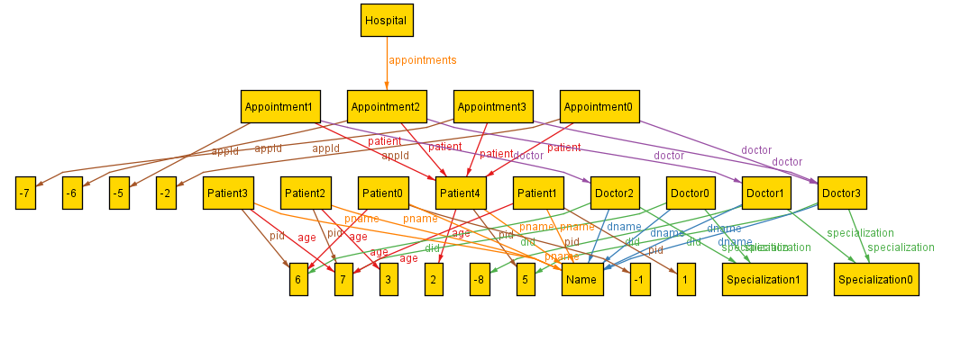

4. System Analysis and Requirements
System analysis is an important phase in software development that identifies the needs, functionalities, and limitations of the system. In the Hospital Management System, analysis is performed to understand how patients, doctors, and appointments interact with each other and how the system can manage these operations efficiently.
The proposed system is formally modeled using Alloy Analyzer to ensure correctness and consistency. The analysis mainly focuses on managing hospital records, maintaining unique identities, validating relationships, and preventing logical conflicts in appointments.
The requirements of the system are divided into functional requirements, non-functional requirements, and system constraints.

4.1 Functional Requirements
Functional requirements describe the main operations and services that the system must perform.

1. Patient Management
- The system shall store patient information.
- Each patient shall have a unique patient ID.
- The system shall prevent duplicate patient records.

2. Doctor Management
- The system shall store doctor information.
- Each doctor shall have a unique doctor ID.
- Duplicate doctor records shall not be allowed.

3. Appointment Management
- The system shall create and manage appointments between patients and doctors.
- Each appointment shall have a unique appointment ID.
- Every appointment must be associated with one patient and one doctor.

4. Validation Rules
- All IDs must contain positive integer values.
- The system shall validate entity relationships before generating instances.

5. Conflict Prevention
- The system shall prevent invalid or duplicate appointments.
- A doctor should not have conflicting appointments with the same patient.

6. Verification and Analysis
- The system shall verify constraints using assertions.
- The system shall generate valid sample instances through Alloy Analyzer.

4.2 Non-Functional Requirements
Non-functional requirements define the quality attributes and performance expectations of the system.

1. Reliability
The system must produce logically correct and consistent results during verification.

2. Accuracy
All hospital records and relationships must be validated accurately without duplication or inconsistency.

3. Maintainability
The Alloy model should be easy to understand, modify, and extend for future enhancements.

4. Scalability
The model should support the addition of more entities and constraints in the future.

5. Usability
The system model should be simple and readable for developers and researchers working with formal methods.

6. Verification Capability
The system must support automatic checking of assertions and constraints using Alloy Analyzer.

7. Performance
The system should efficiently generate valid instances within the specified scope.

4.3 System Constraints
System constraints define the limitations and rules that must always be satisfied within the Hospital Management System.

1. Unique IDs Constraint
- Every patient must have a unique patient ID.
- Every doctor must have a unique doctor ID.
- Every appointment must have a unique appointment ID.

2. Positive Value Constraint
- Patient IDs must be greater than zero.
- Doctor IDs must be greater than zero.
- Appointment IDs must be greater than zero.

3. Relationship Constraint
- Every appointment must link exactly one patient with exactly one doctor.

4. Appointment Constraint
- Duplicate appointments are not allowed.
- Invalid doctor-patient appointment conflicts must be prevented.

5. Scope Limitation
- The model focuses only on patients, doctors, and appointments.
- Advanced hospital modules such as billing, pharmacy, and laboratory systems are outside the scope of this project.

6. Alloy Scope Constraint
- The system operates within a limited Alloy scope during verification and instance generation.
- Objects and integer ranges are bounded according to the run command specifications.

5. System Design
The Hospital Management System is designed using Alloy Analyzer. The system contains three main entities: Patient, Doctor, and Appointment. The design ensures proper relationships and validation between all entities.

5.1 Core Entities
The core entities of the system are:
- Patient
- Doctor
- Appointment
These entities store the main information of the hospital system.

5.2 Patient Module
The Patient module manages patient records. Each patient has a unique patient ID.

5.3 Doctor Module
The Doctor module manages doctor information. Each doctor is assigned a unique doctor ID.

5.4 Appointment Module
The Appointment module connects patients with doctors and stores appointment details.

5.5 Relationship Modeling
Relationships are defined between patients, doctors, and appointments. Each appointment links one patient with one doctor.
6. Alloy Model Specification
The system is formally modeled using Alloy Analyzer to verify correctness and consistency.

6.1 Signatures (sig)
Signatures define the main entities of the system such as Patient, Doctor, and Appointment.

6.2 Facts and Constraints
Facts define rules that must always remain true, such as unique IDs and positive values.

6.3 Predicates
Predicates are used to generate sample system instances.

6.4 Assertions
Assertions are used to check whether system rules are valid.

6.5 Run and Check Commands
Run commands generate instances, while check commands verify assertions.
7. Implementation Details
The implementation defines how entities and rules are modeled in Alloy.

7.1 Patient Entity Implementation
The Patient entity stores patient IDs and ensures uniqueness.

7.2 Doctor Entity Implementation
The Doctor entity stores doctor IDs and validates unique records.

7.3 Appointment Entity Implementation
The Appointment entity connects doctors and patients.

7.4 Validation Rules
Validation rules ensure positive IDs and valid relationships.

7.5 Double Booking Prevention
The system prevents invalid duplicate appointments between the same doctor and patient.
8. Testing and Verification
Testing and verification are performed using Alloy Analyzer.

8.1 Model Verification
The model is verified against defined constraints.

8.2 Assertion Checking
Assertions are checked to ensure system correctness.

8.3 Instance Generation
The Alloy Analyzer generates valid sample instances.

8.4 Error Detection and Analysis
The system identifies logical inconsistencies and errors during verification.
9. Results and Discussion
The results show that the system successfully satisfies the defined constraints and validation rules.

9.1 Generated Instances
Valid instances of patients, doctors, and appointments are generated.

9.2 Constraint Validation
All uniqueness and relationship constraints are verified successfully.

9.3 System Reliability Analysis
The system demonstrates reliable and consistent behavior during testing.

10. Advantages of Using Formal Methods
- Improves system reliability
- Detects logical errors early
- Reduces development risks
- Ensures accurate system behavior
- Provides formal verification

11. Challenges and Limitations
- Formal modeling can be difficult for beginners
- Large systems may become complex
- Limited to defined scope and constraints

12. Future Enhancements
Future improvements may include:
- Billing management
- Pharmacy module
- Laboratory management
- Online appointment scheduling
- Patient medical history management

13. Conclusion
The Hospital Management System was successfully modeled using Alloy Analyzer. The system ensures uniqueness, valid relationships, and appointment consistency through formal verification techniques.

14. References
- Alloy Analyzer Documentation
- Software Engineering Books
- Research Papers on Formal Methods
- Hospital Management System Studies

15. Appendix

15.1 Complete Alloy Code
Contains the complete Alloy model of the Hospital Management System.

15.2 Screenshots of Alloy Analyzer Output
Includes generated instances and verification results.

15.3 Test Cases and Assertions
Contains assertions and test scenarios used for verification.

Z-Notation
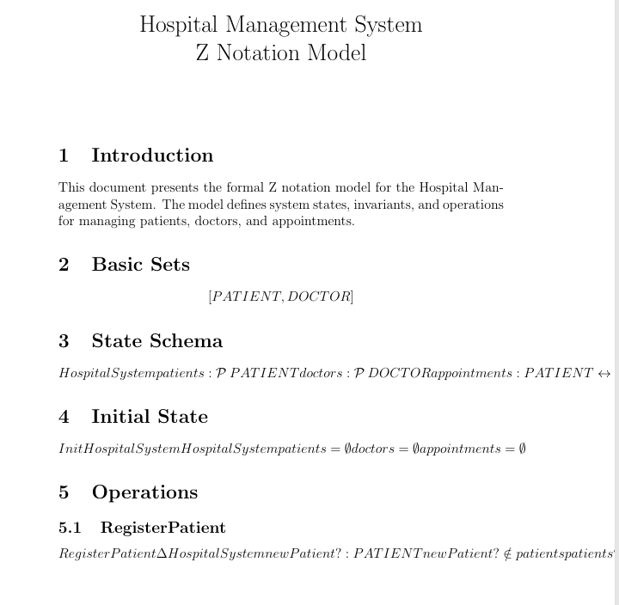
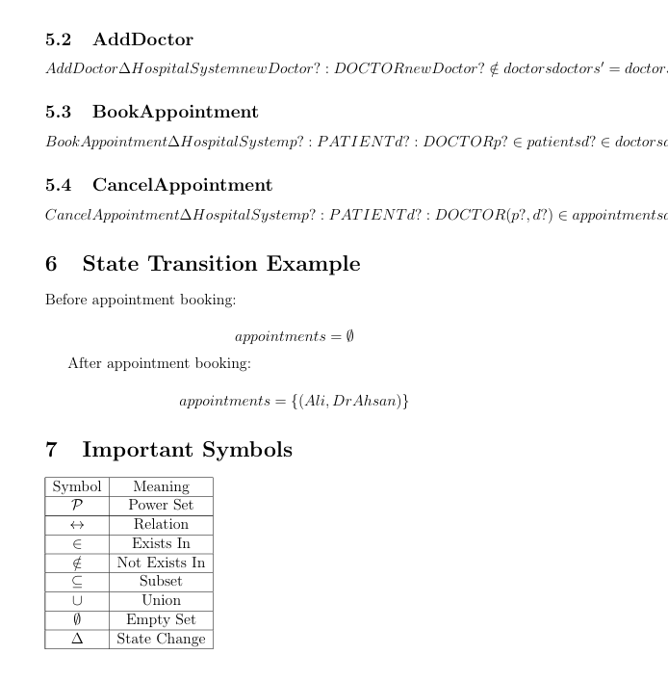
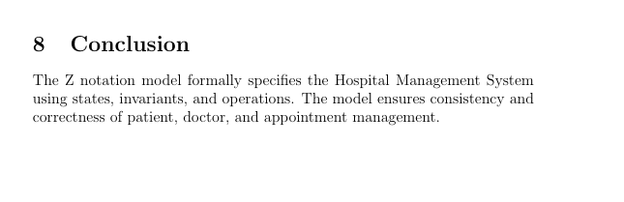
VDM

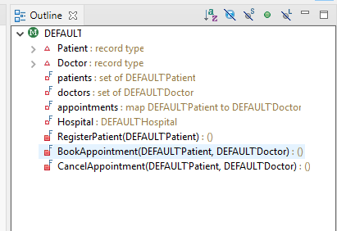
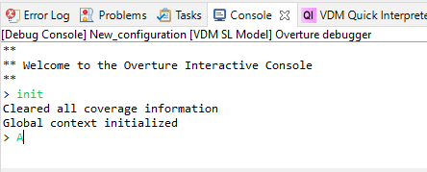

CI-Pipeline
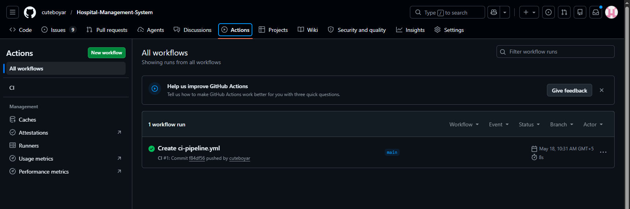
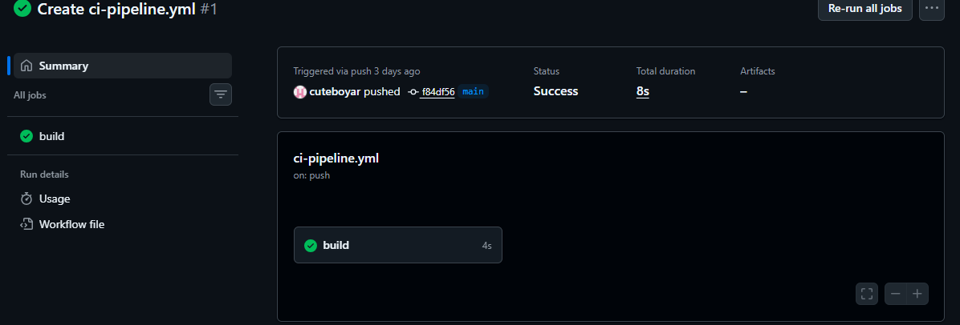
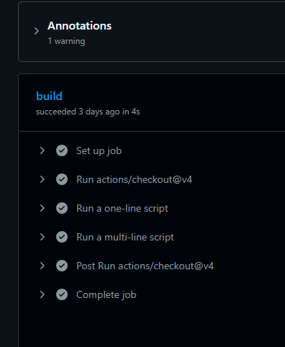

Requirements/ Issues
